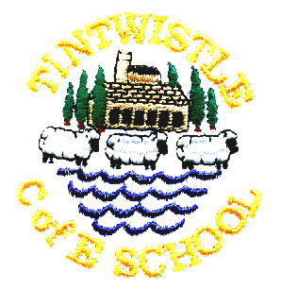
Tintwistle C. E. (A) Primary School

15th November 2019

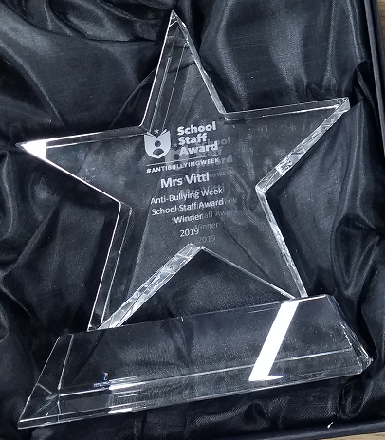
National Anti-Bullying Award
This week is national anti-bullying week and we are delighted to be able to tell you that Mrs Vitti has won the Anti-Bullying Alliance’s Primary School Staff Award 2019. Several Tintwistle staff were nominated by our pupils and Harriet and Amy chose to write about Mrs Vitti. The nominations were posted off and judged by a panel of children. Mrs Vitti was due to visit the Houses of Parliament on Wednesday to be presented with her award at a special celebration event but as parliament is closed due to the election the event has been cancelled and rescheduled for January. We’ll just have to make do with a photo of the award for now!

Non Uniform Day Friday 29th November
Children are invited to come in non-uniform in return for bottles (full please!) for our bottle stall at the fair. We will also be collecting tombola items.

Christmas Fair in School – Friday 29th November 5.00pm -7.00pm
Everyone welcome to come along and get festive. Stalls, refreshments, children’s games and a chance to meet Father Christmas!

Monday 2nd December
School trip to Jodrell Bank. Please note that this trip is not suitable for nursery children and the nursery will be open as normal. We’ll make sure to have lots of fun activities so they don’t feel left out.

School Carol Service – Wednesday 18th December
Please meet at Christ Church at 9.00am, everyone welcome. If you would like to wear your Christmas jumper any donations made for Christmas Jumper Day will be sent to Save the Children.

Theatre Performance in School Wednesday 18th December
Quantum Theatre will be bringing their Christmas show to us this year, we are very much looking forward to The Nutcracker. Thanks to the PTA for funding this very popular event.

Christmas Play
This year’s play is ‘Lights, Camel, Action!’ and all the children in the school, including nursery, are involved. Please let us know if your child is unable to attend all the performances so that we can make alternative arrangements. Monday’s performance is a dress rehearsal and is a little unpolished, but it is a good opportunity to bring younger siblings and we often have spare seats. Please do not bring babies to the evening performances as they often disturb the show and it is unfair to the children. The good news is that tickets are free, but seats are strictly limited due to fire regulations, we are happy to accommodate wheelchairs but it is helpful if you let us know when booking (just note it on the slip).

School closes for Christmas at 3.30pm on Friday 20th December and re-opens on Monday 6th January.

Child’s name …………………………………………………………… Class …………………………………………………….

Please send me the following tickets Spares (if any
(maximum 2 per family, pick one date) available, maximum 2)

Monday 9th December at 2.00pm ……………. ……………

Tuesday 10th December at 6.30pm ……………. ……………

Thursday 12th December at 6.30pm ……………. ……………

No more than 2 tickets in each column (apologies if you think it is obvious but columns go downwards, rows go across). Ticking every box will not get you extra tickets!

Please note that tickets will be issued on Thursday 5th December. We always have spare seats for the Monday afternoon performance so it is possible to request more seats for that date.

