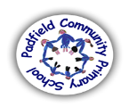
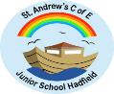
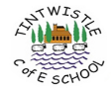
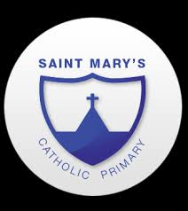
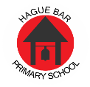
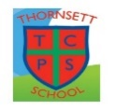
Family Support for New Mills
&
Glossopdale School clusters

FAMILY SUPPORT TEAM
The Family Support Team covering Glossopdale and New Mills School is committed to providing support to ensure all children in the local area get the best start in life.
We understand that family life can be difficult at times and our aim is to offer support to families within the community with children from primary through to secondary school in order to provide continuity with their outcomes.
Our Aim
We want to ensure that parents and carers have access to support and advice that will help them in their parenting role so that their children can grow up to achieve positive outcomes. We aim to work with families in and open, honest, yet constructive way. We offer universal and targeted support for children aged 4 -16 years across our cluster primary schools and two main secondary schools.
Our Services
We can offer a range of services for parents/carers and children/young people in order to maximise outcomes for families.
These include:
- Parenting support – in the home and through school
- Signposting to other services
- Teenage support and guidance
- Managing behaviour and building family relationships
- Supporting attendance concerns
- Self-esteem and anxiety support
- Early Help Assessments including parent carer toolkit
- 1-1 to support within families
- Connecting communication between services to get the best outcomes for the family and young person as an advocate to achieving successful outcomes
How these services will be provided
- This is provided through an early help assessment which can be completed within school or within the family home or if preferred at an alternative setting.
- Workshops will be provided to support specific needs in response to what is required in the area. This will include emotional resilience and parenting support.
- Targeted work through schools within focused group work.

How to refer
Professionals – Complete the internal referral form and send to the family support service on the email below.
Families – If you feel your family may benefit from our service please contact your school pastoral lead to discuss further and they can support you with making a referral.
Any enquiries to familysupport@glossopdale.school

Further support may be found on the following websites
https://www.safe4me.co.uk/resources/ - Advice and Support for parents, carers and guardians as part of our commitment to working in partnership to keep children and young people safe.
https://services.actionforchildren.org.uk/derbyshire/ - committed to helping the most vulnerable children and young people in the UK break through injustice, deprivation and inequality.
https://www.changegrowlive.org/young-people/derbyshire-cgl-young-peoples-service Derbyshire CGL is a free and confidential drug and alcohol outreach service for young people up to the age of 19.

