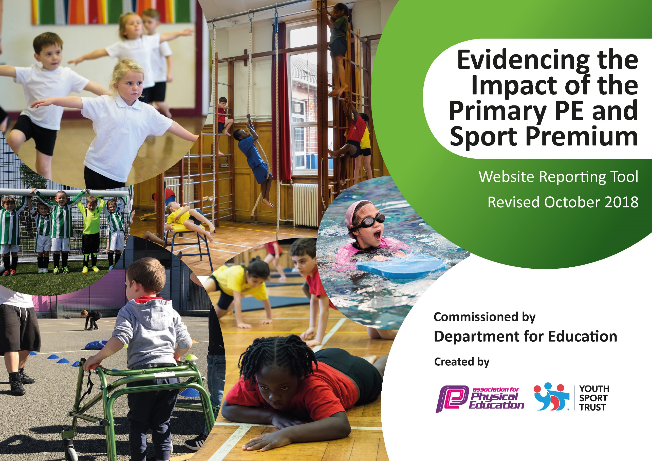
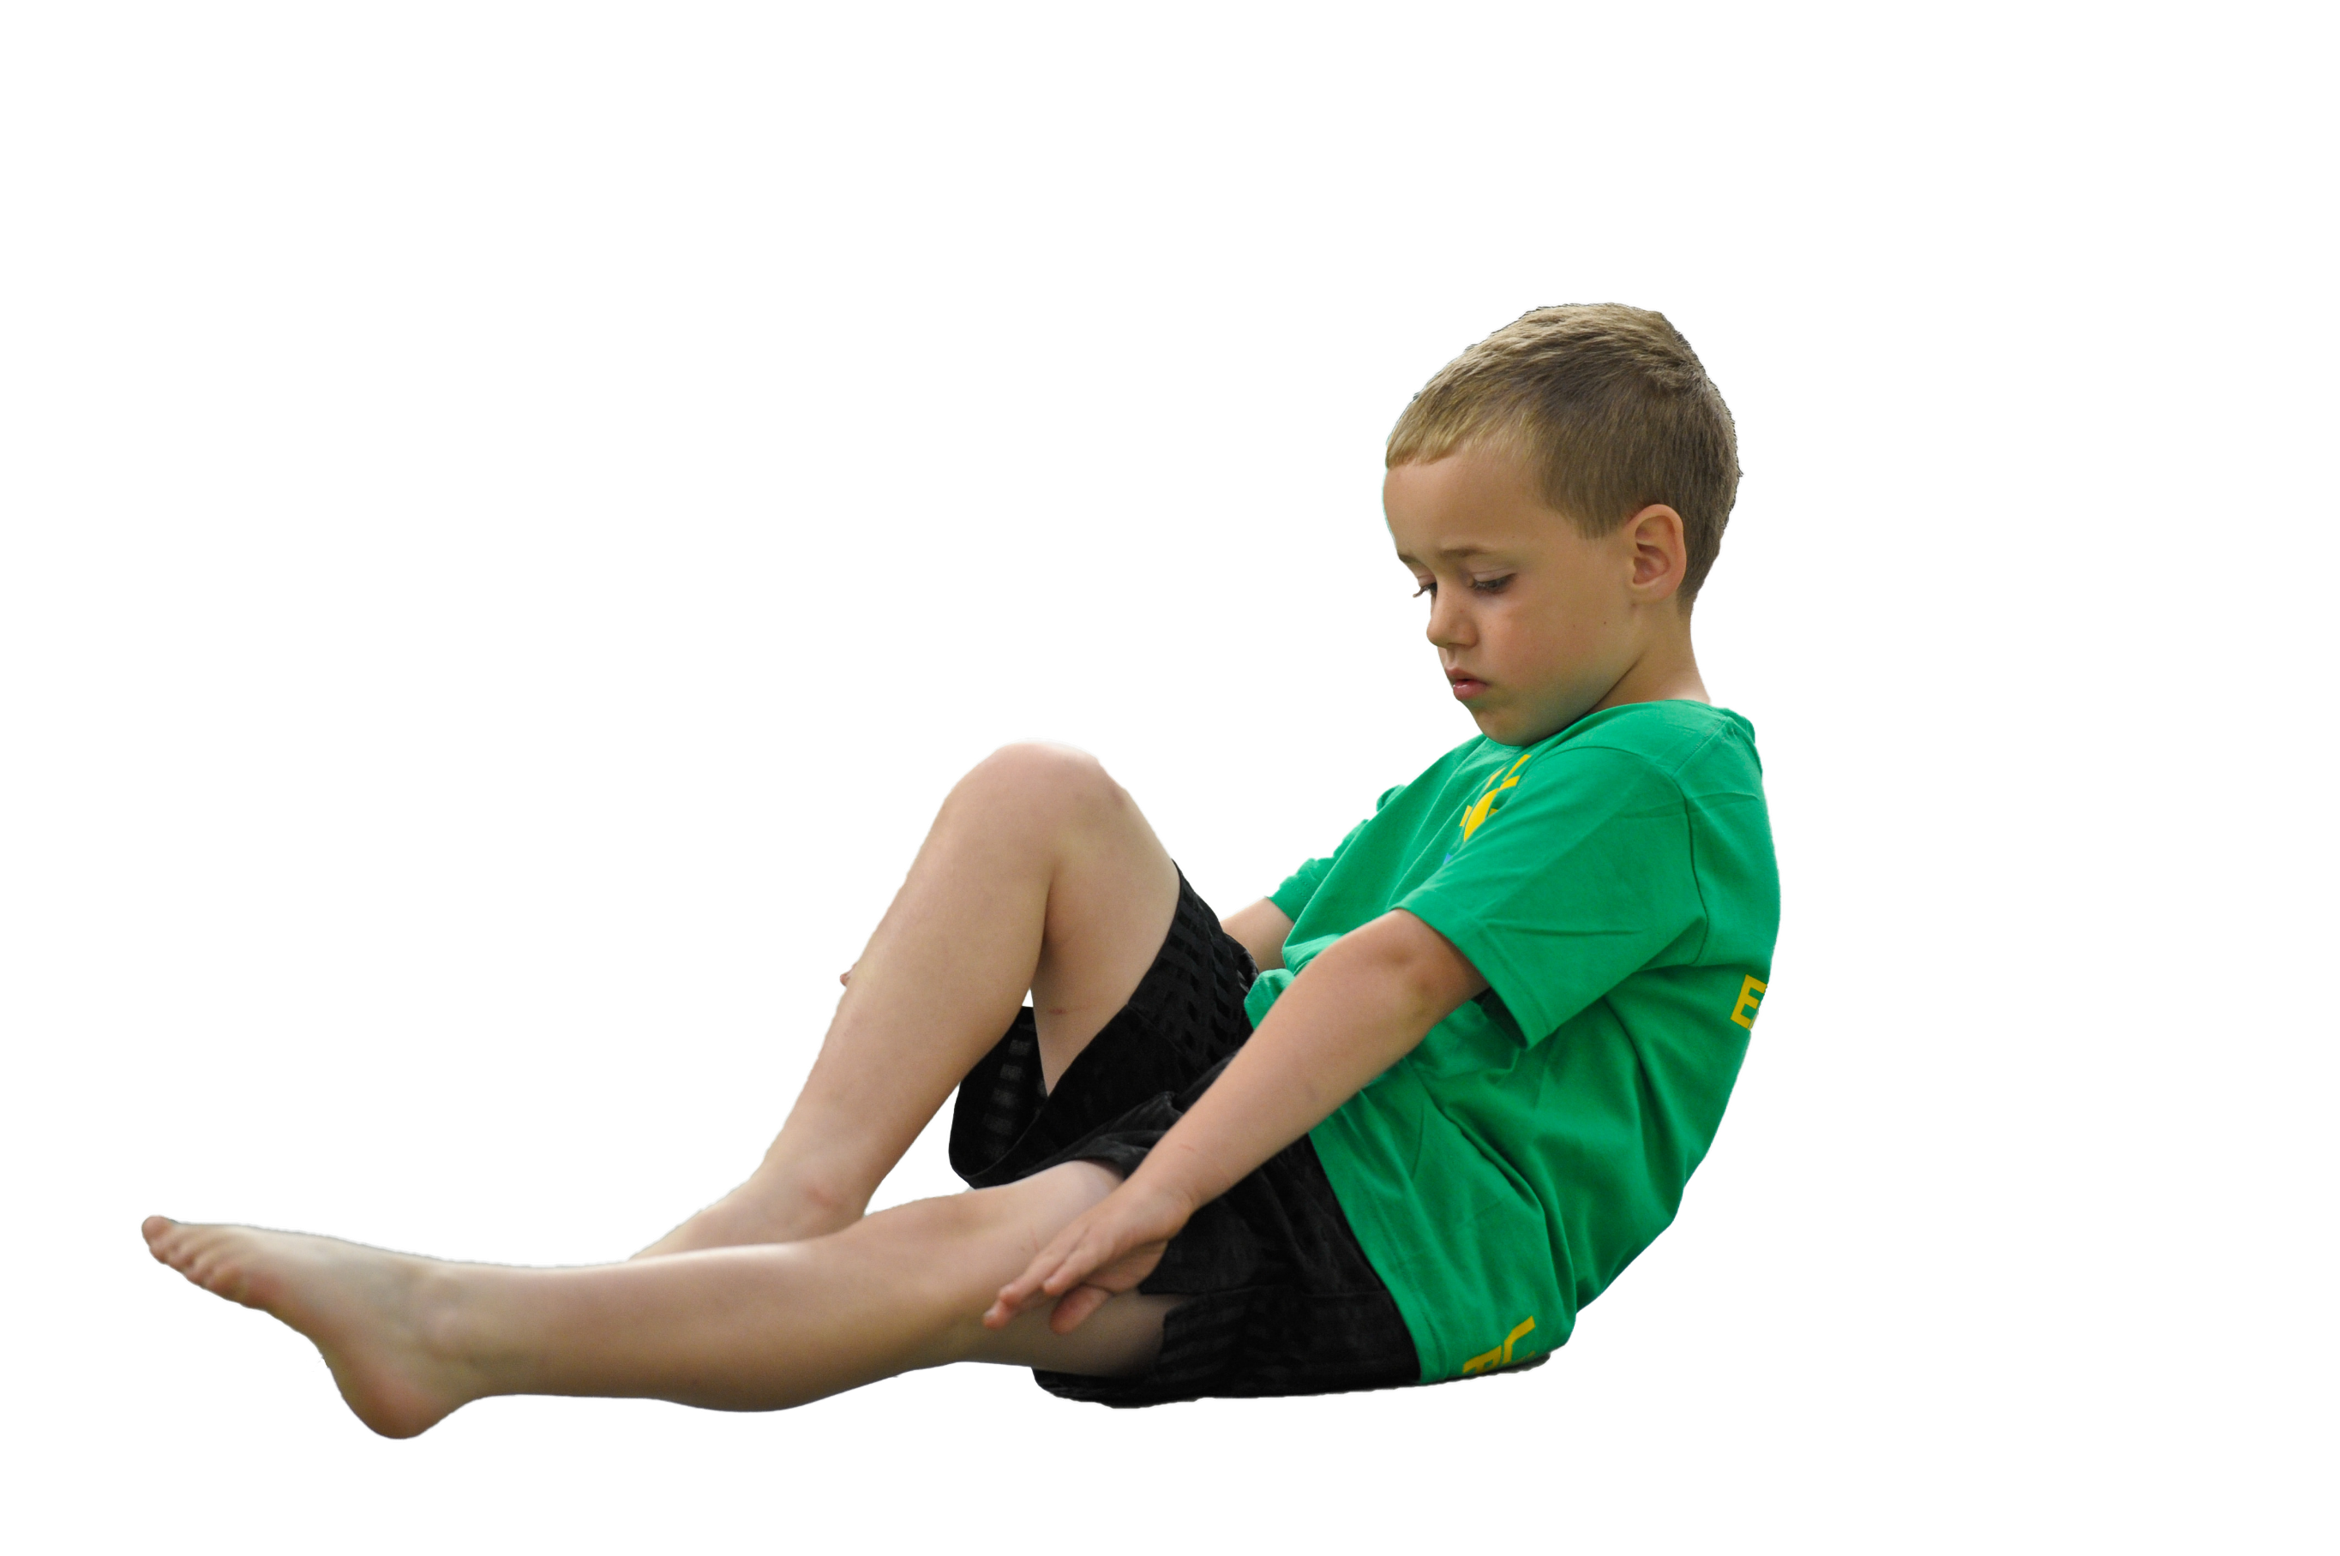
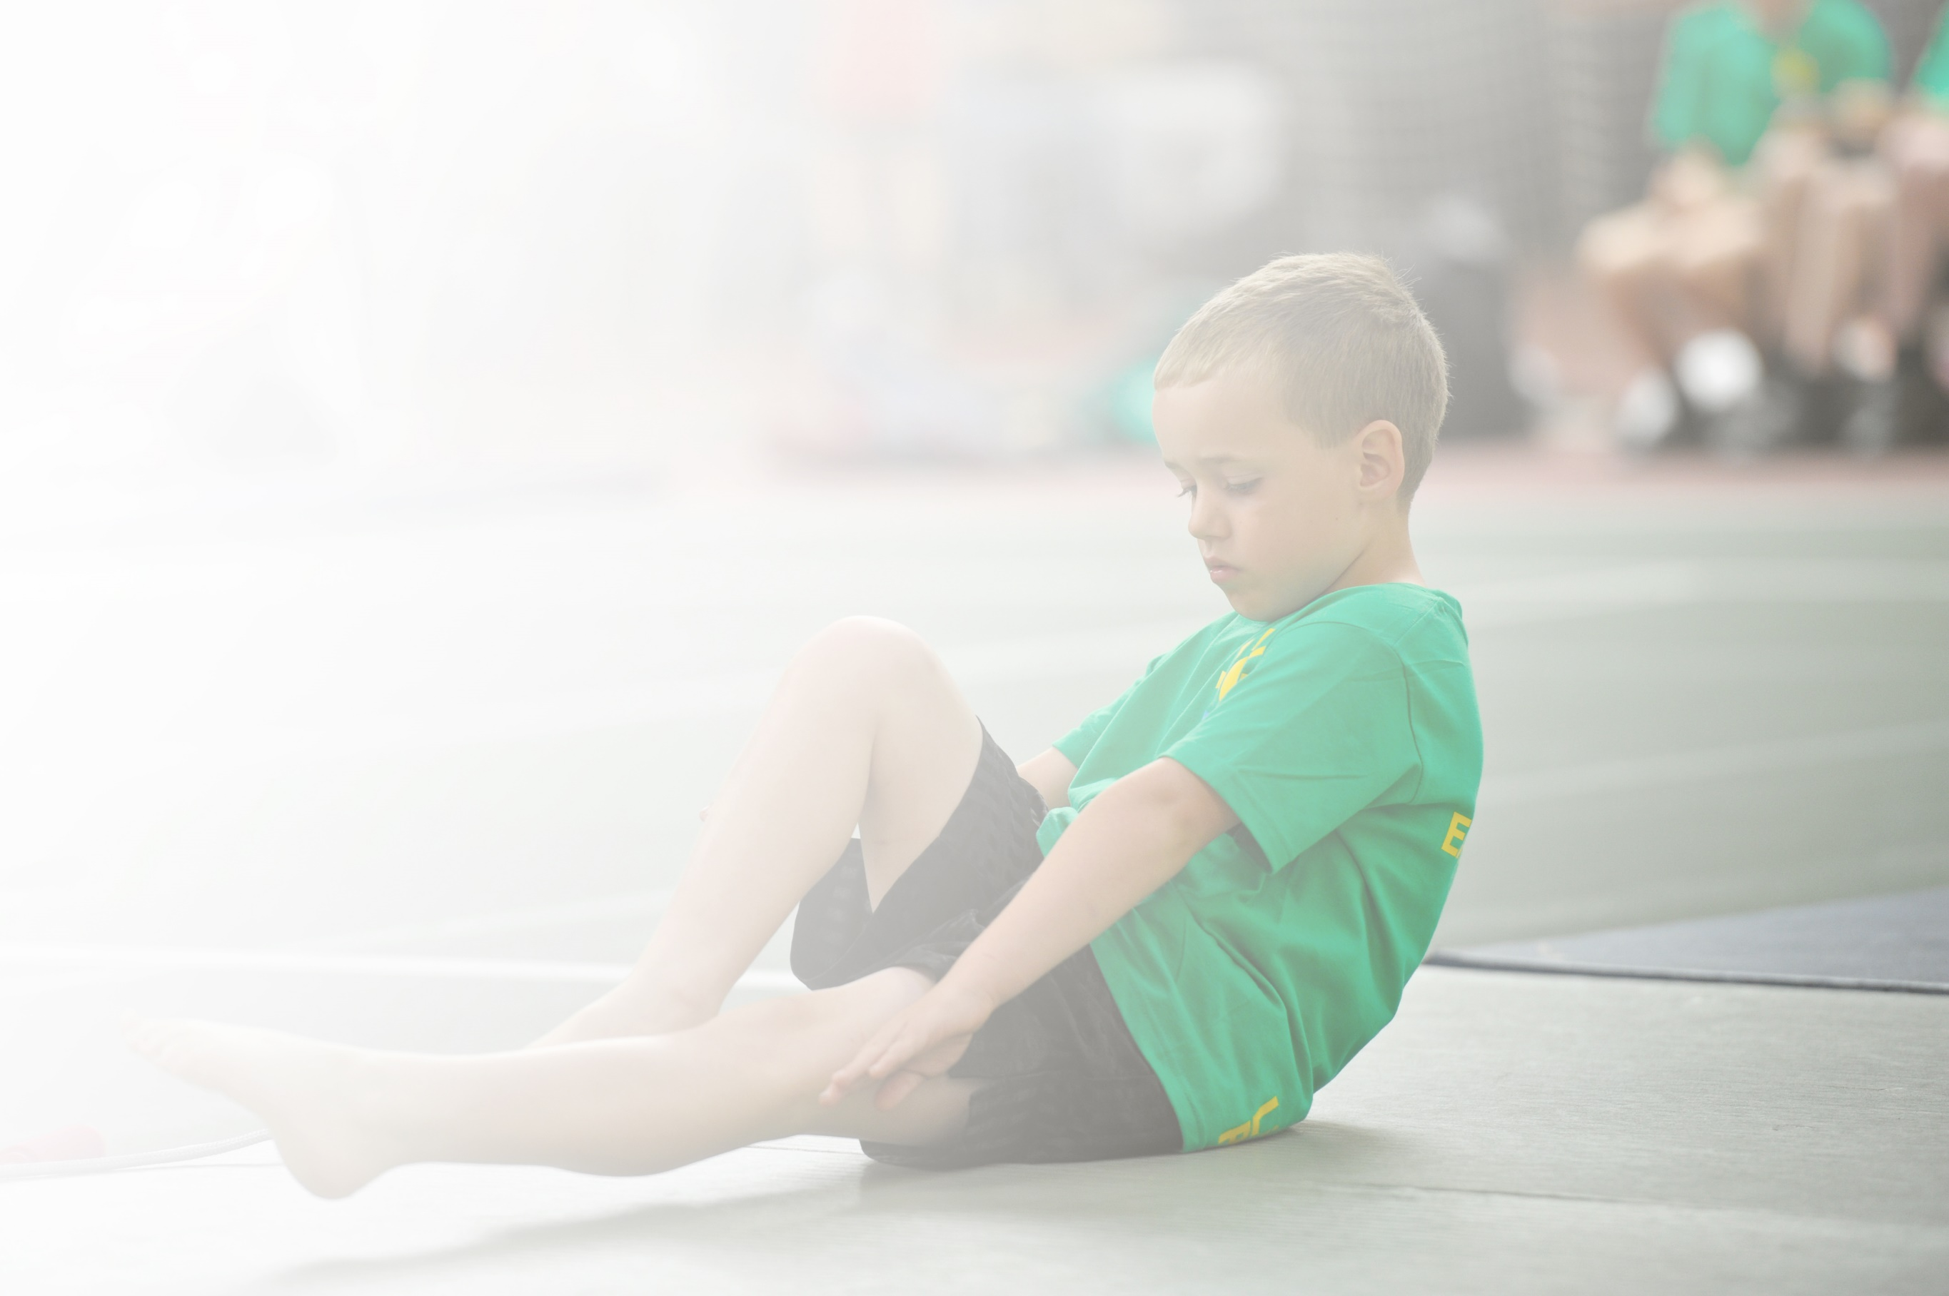
Schools must use the funding to make additional and sustainable improvements to the quality of Physical Education, Sport and Physical Activity (PESPA) they offer. This means that you should use the Primary PE and Sport Premium to:

- Develop or add to the PESPA activities that your school already offer
- Build capacity and capability within the school to ensure that improvements made now will benefit pupils joining the school in future years

Please visit gov.uk for the revised DfE guidance including the 5 key indicators across which schools should demonstrate an improvement. This document will help you to review your provision and to report
your spend. DfE encourages schools to use this template as an effective way of meeting the reporting requirements of the Primary PE and Sport Premium.

We recommend you start by reflecting on the impact of current provision and reviewing the previous
spend. Under the Ofsted Schools Inspection Framework, inspectors will assess how effectively leaders use the Primary PE and Sport Premium and measure its impact on outcomes for pupils, and how effectively governors hold them to account for this.

Schools are required to publish details of how they spend this funding as well as on the impact it has on pupils’ PE and sport participation and attainment by the end of the summer term or by 31 July 2019 at the
latest.
We recommend regularly updating the table and publishing it
on your website throughout the year, as evidence of your
ongoing review into how you are using the money to
secure maximum, sustainable impact. To see an
example of how to complete the table please
click HERE.

Support for review and reflection - considering the 5 key indicators from DfE, what development needs are a priority for your setting and your students now and why? Use the space below to reflect on previous spend, identify current need and priorities for the future.

Key achievements to date: 2019-2020 | Areas for further improvement and baseline evidence of need:
- Children achieve well in all areas of PE and show good progression across all year groups.  - Teachers are confident to teach in all areas of PE  - Planning and resources are in place to ensure that both of the above happen.  - Children in school are inspired to gain new experiences and try new things.  - Forest school sessions are taking place for every year group. | - The engagement of all pupils in regular physical activity.  - To invited local clubs into school to enhance working with clubs in the local environment.  - Increased confidence, knowledge and skills of all staff in teaching PE and sport.  - Broader experience of a range of sports and activities offered to all pupils.  - increased participation in competitive sport.

Meeting national curriculum requirements for swimming and water safety | Please complete all of the below:
What percentage of your current Year 6 cohort swim competently, confidently and proficiently over a distance of at least 25 metres?  N.B. Even though your children may swim in another year please report on their attainment on leaving  primary school. | 95%  Swimming had to stop due in March 2020 to Covid 19.
What percentage of your current Year 6 cohort use a range of strokes effectively [for example, front crawl, backstroke and breaststroke]? | 95%  Swimming had to stop due to March 2020 to Covid 19.
What percentage of your current Year 6 cohort perform safe self-rescue in different water-based situations? | 95%  Swimming had to stop due to March 2020 to Covid 19.
Schools can choose to use the Primary PE and Sport Premium to provide additional provision for swimming but this must be for activity over and above the national curriculum requirements. Have you used it in this way? | Yes/No

Action Plan and Budget Tracking
Capture your intended annual spend against the 5 key indicators. Clarify the success criteria and evidence of impact that you intend to measure to evaluate for students today and for the future.

Academic Year: 2018/19 | Total fund allocated: £ | Date Updated:
Key indicator 1: The engagement of all pupils in regular physical activity – Chief Medical Officer guidelines recommend that primary school children undertake at least 30 minutes of physical activity a day in school |  |  |  | Percentage of total allocation:
 |  |  |  | %
School focus with clarity on intended impact on pupils: | Actions to achieve: | Funding allocated: | Evidence and impact: | Sustainability and suggested next steps:
Daily mile track is used for 10 minutes each day for each class.  Use external coaches to provide high quality PE sessions and School Sport (extra-curricular) opportunities for all children.  Continue to provide high quality PE/ Forest school resources. | -Timetable for the mile track.  - Active Tameside run a weekly after school club. The activity changes each half term.  - We have used the money to replenish Forest School equipment this year.  -Audit of P.E equipment. | £1000  £100 | - Children are able to beat their personal best scores on the mile track. All children are able to access the mile track.  - Children are able to be involved with Forest School activities, using the correct equipment. | Carried forward this had to be suspended due to Covid 19.
Key indicator 2: The profile of PESSPA being raised across the school as a tool for whole school improvement |  |  |  | Percentage of total allocation:
 |  |  |  | %
School focus with clarity on intended impact on pupils: | Actions to achieve: | Funding allocated: | Evidence and impact: | Sustainability and suggested next steps:
Continue to employ Play leader/replenish stock (where necessary).  To provide children in Year 5 with leadership opportunities.  To provide swimming for children in Year 5 and 6 every year. | -Sports council to order new playtime equipment with SJ.  -Dawn Richardson came into school to deliver leadership training for the Year 5 children. 05/10/20.  - Children only went until March 2020. They were unable to complete their swimming lessons due to Covid 19. | £100  £200  £3000 (Every 2 years) | - Suspended due to Covid 19.  - Successfully completed – children now more confident in providing children with outside activities –to train next year’s Year 5. Children lead at lunchtimes/playtimes and in lessons.  - Children complete their water safety and they are able to swim a variety didn’t lengths. | Continue target next year.  Complete with the new year 5 children next year.  Continue with Y5/6 next year.

Key indicator 3: Increased confidence, knowledge and skills of all staff in teaching PE and sport |  |  |  | Percentage of total allocation:
 |  |  |  | %
School focus with clarity on intended  impact on pupils: | Actions to achieve: | Funding  allocated: | Evidence and impact: | Sustainability and suggested  next steps:
Continue to provide high quality training for all teaching staff to ensure that all children receive high quality PE and Sport provision.  Continue to release all staff to ensure that pupils can attend a range of sporting opportunities throughout the year/CPD. | - SJ to attend subject leader courses.  - Gymnastics course 22/10/19  - Activate your school day 03/02/20  - Active learning 12/03/20  Feedback to the other staff and deliver sessions.  -Sue, Mrs Griffin, Miss Jones, Miss Crookes, Miss Crowe, Mrs Doyle, Mrs Bott released with take children to P.E events. | £500 | All PE lessons across school graded as good or better.  - High quality sports provision in place.  -Teachers having more confidence and skills.  -Use High Peak SSP to provide high quality CPD.  - Children are able to participate in many sporting activities around the local area and within the high peak. | Suspended due to Covid 19.  Continue next year.  -Many sporting events did not occur this year due to Covid 19.
Key indicator 4: Broader experience of a range of sports and activities offered to all pupils |  |  |  | Percentage of total allocation:
 |  |  |  | %
School focus with clarity on intended  impact on pupils: | Actions to achieve: | Funding  allocated: | Evidence and impact: | Sustainability and suggested  next steps:
Additional achievements:  Further develop our ‘Try something new week’ promoting local sporting clubs. | - All Stars Cricket Club came in to deliver sessions for Y1/2 and Y3/4 for 6 weeks. (This was suspended due to Covid 19.)  - Sports week- Try something new. | £1000 | - The children enjoyed a coach coming in to teach them cricket. Many of the children joined the club outside of school. | Suspended due to Covid 19.  Continue next year.
Key indicator 5: Increased participation in competitive sport |  |  |  | Percentage of total allocation:
 |  |  |  | %
School focus with clarity on intended  impact on pupils: | Actions to achieve: | Funding  allocated: | Evidence and impact: | Sustainability and suggested  next steps:
School to buy into Glossopdale SSCO provision to enable a wide range of inter school sporting activities.  School to continue to buy into High Peak School Sport Partnership to enable a wider range of competitions and resources. | -Football league for Y5/6 boys and girls. Autumn term.  -Y3/4 Dance event 25/11/20  -Y5/6 Athletics event 26/02/20  -Change 4 Life event 29/01/20  -New Mills Football event 07/02/10 | £570 | -More children attending sporting activities at other schools.  -More children competing with other schools. | Suspended due to Covid 19. This will be continued next year.

